Capstone Project Weekly Progress Report

|  |  |
| --- | --- |
| Semester | Fall-2024 Semester 3rd |
| Course Code | AML-3406 |
| Section | Section 1 |
| Project Title | Car Damage Detection |
| Group Name | Group B |
| Student names/Student IDs | Sakshi (C0908000)  Bansil Patel (C0912873)  Harsh Mohile (C0912872)  Meet Patel (C0910378) – TL  Rachit Bhatt (C0902810) |
| Reporting Week | Week 4 |
| Faculty Supervisor | William Pourmajidi |

# **Grade the level of collaboration from different aspects between team members:**

(use: good, medium, below expectation)

|  |  |  |  |  |
| --- | --- | --- | --- | --- |
| Sakshi | Bansil Patel | Harsh Mohile | Meet Patel | Rachit Bhatt |
| Good | Good | Good | Good | Good |

# **Tasks outlined in the previous Weekly Progress Report for this reporting week at the individual level and group level**

* 1. Individual tasks (each team member)

Sakshi: Learning VS Code + Learning GitHub.

Bansil Patel & Meet Patel: Learning VS Code + Exploring Dataset.

Harsh Mohile & Rachit Bhatt: Learning VS Code + Creating Branches for automation and deployment, and over Git Management.

2.2 Your team’s tasks

* Adapting VS-Code as IDE for development and version control.
* GitHub Management.
* Exploring Dataset.

# **Progress made in Reporting Week at an individual level and group level**

* 1. Individual progress

Sakshi: Understood basics of VS-Code Extensions and GitHub.

Bansil Patel:

Harsh Mohile: Worked on the quality-assurance branch for applying test automation.

Meet Patel:

Rachit Bhatt: Worked on the production branch for launching the tested piece of solution to the cloud.

* 1. Your team’s progress
* GitHub Management for Deployment and Test-Automation.

# **The areas/tasks you could not make progress and/or complete as scheduled or the difficulties encountered in this reporting week at individual level and group level.**

* 1. Individual project blockers

Sakshi: N/A

Bansil Patel: N/A

Harsh Mohile: N/A

Meet Patel: N/A

Rachit Bhatt: N/A

* 1. Your team’s project blockers
* Since the tasks of this scrum were quite smooth, 🤞luckily; there were no blockers in this week.

# **Tasks to be completed in next week at individual level and group level**

* 1. Individual tasks

Sakshi: Research on CI/CD Pipelining for ML-Ops.

Bansil Patel & Meet Patel: Applying various models initially on the dataset.

Harsh Mohile & Rachit Bhatt: Research on Docker for Deployment.

* 1. Your team’s tasks
* Exploring and understanding the dataset.
* Research on Docker for Deployment.

# **Include the tasks from your sprint planning (Github/Zenhub) for the present period.**

**Figure 1:** Status Chart of GitHub Issues in Milestone

# **Include charts/graphs (e.g., burn down charts) from your project management tool (Github/Zenhub) that shows your progress for the period of this report.**

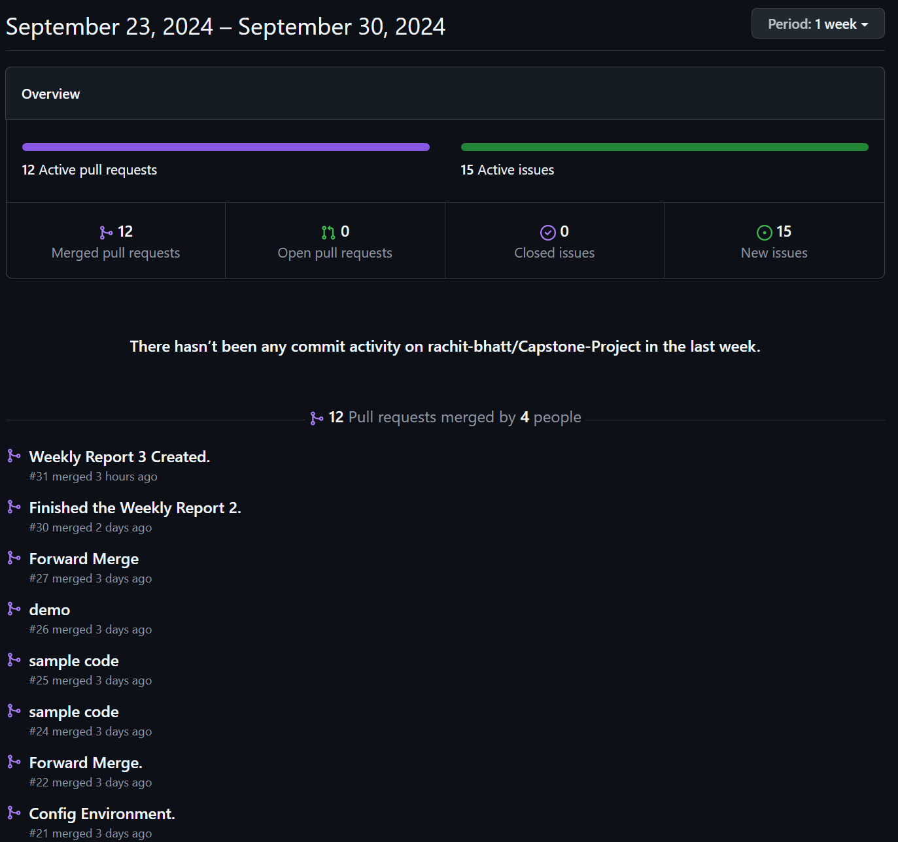

**Figure 2:** Contributors in the Week

# **Include a note and address to your project Github with list of codes uploaded/updated on Github in this reporting week.**

[GitHub](https://www.github.com/rachit-bhatt/Capstone-Project): <https://www.github.com/rachit-bhatt/Capstone-Project>

**Figure 3:** Applying NN on a Sample Dataset

**Figure 4:** Model Evaluation Summary

**Figure 5:** Exception – Progress Blocker